H.T No
Regulations:
A18

Sreenidhi Institute of Science and Technology
(An Autonomous Institution)
Code No: 7AC41 Date: 23-Dec-2022 (FN)

B.Tech II-Year I- Semester (A18) Special Supplementary Examination - December-2022
BASIC ELECTRICAL ENGINEERING (CSE and it)

Time: 3 Hours Max.Marks:70

Note: a) No additional answer sheets will be provided.
b) All sub-parts of a question must be answered at one place only, otherwise it will not be valued.
c) Missing data can be assumed suitably.

ANSWER ANY 5 OUT OF 8 QUESTIONS. EACH QUESTION CARRIES 14 MARKS.

Bloom's Cognitive Levels of Learning (BCLL)
Remember | L1 | Apply | L3 | Evaluate | L5
Understand | L2 | Analyze | L4 | Create | L6

 |  |  | BCLL | CO(s) | Marks
1. | a) | State and explain Norton’s theorem. | L1 | CO1 | [7M]
 | b) | Develop Norton’s equivalent circuit across terminals x and y.  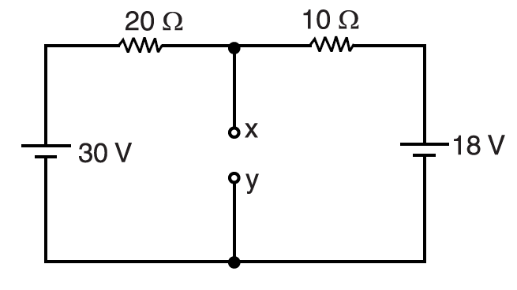 | L4 | CO1 | [7M]
2. | a) | Discuss about the generation of alternating voltages and currents. | L2 | CO2 | [7M]
 | b) | Explain R.M.S. value and average value of alternating quantity. | L2 | CO2 | [7M]
3. | a) | Explain the principle of operation of DC motor. | L2 | CO3 | [7M]
 | b) | Derive EMF equation of D.C generator. | L6 | CO3 | [7M]
4. | a) | A 10kVA, 2000/400V single phase transformer has R₁=5Ω; X₁= 12Ω; R₂=0.2Ω and X₂=0.48Ω. Determine the equivalent impedance of the transformer referred to (i) primary side (ii) secondary side . | L4 | CO4 | [7M]
 | b) | Discuss about equivalent circuit of a transformer. | L2 | CO4 | [7M]
5. | a) | Derive relation between line and phase quantities of a delta connected three phase system. | L6 | CO5 | [7M]
 | b) | A 3-ϕ, 400V, 50Hz A.C supply is feeding a 3-ϕ delta connected load with each phase having a resistance of 25Ω and a inductance of 0.15H in series. Determine line current and phase current. | L4 | CO5 | [7M]
6. | a) | Explain the working principle of a permanent magnet moving coil instruments. | L2 | CO6 | [7M]
 | b) | Describe the features common to all indicating instruments. | L2 | CO6 | [7M]
7. | a) | In the below circuit diagram determine Voltage across 4Ω resistor using super position theorem.  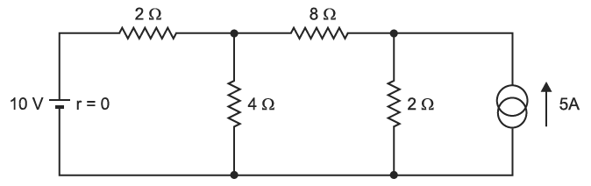 | L5 | CO1 | [5M]
 | b) | Define Active power , reactive power and apparent power. | L2 | CO2 | [5M]
 | c) | Explain how the iron losses can be minimized. | L2 | CO3 | [4M]
8. | a) | Discuss about the practical transformer on load. | L2 | CO4 | [5M]
 | b) | What is rotating magnetic field? | L1 | CO5 | [5M]
 | c) | List out the advantages and disadvantages of moving iron instruments. | L1 | CO6 | [4M]

-- 00 -- 00 –

